Fuzzy Logic In Washing Machine

**Abstract**

Nowadays washing machines are a common thing in the houses. Washing machines enable us automatically washing clothes rather than a traditional approach like washing clothes manually with technology growth washing machines diversifies. Washing machines can build with more sophisticated w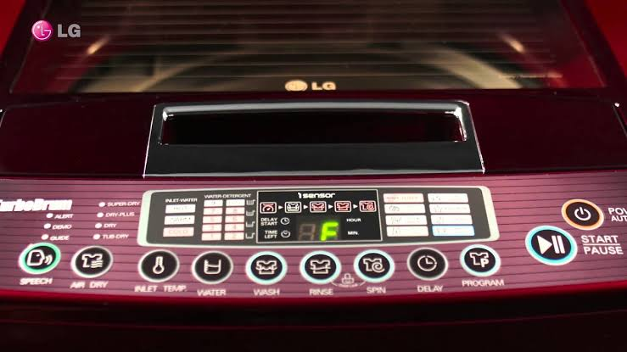ay. A goody way to build with Fuzzy Logic. We can create washing machines with additional tools like automatic water selection,automatic detergent selection. Fuzzy logic enables us to control complex systems more effectively than traditional approaches. In this project we have fuzzy logic controller which as two inputs to approximate correct wash time of washing machine.

**Problem Definition**

Our problem using washing machine unnecessarily.When we use washing machines, generally select the length of wash time based on the amount of clothes wish to wash. We can automate this for reduce used unnecessary electrical power also use washing machine more rapidly. We can also collect data with this process to using future.

**Fuzzy Logic**

The term fuzzy refers to things which are not clear or are vague. In the real world many times we encounter a situation when we can’t determine whether the state is true or false, their fuzzy logic provides a very valuable flexibility for reasoning. In this way, we can consider the inaccuracies and uncertainties of any situation.

**ARCHITECTURE**

Fuzzy Logic Architecture contains four parts :

* RULE BASE: It contains the set of rules and the IF-THEN conditions provided by the experts to govern the decision making system, on the basis of linguisticfuzzy-logic_1.png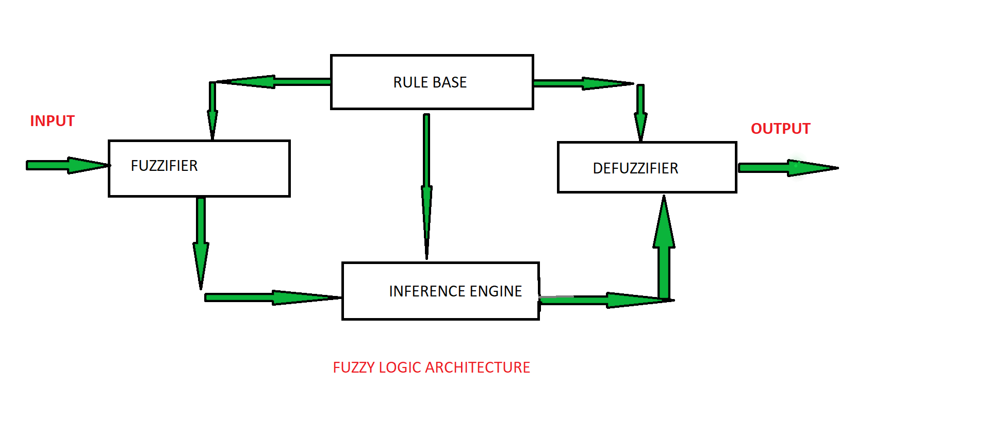 information. Recent developments in fuzzy theory offer several effective methods for the design and tuning of fuzzy controllers. Most of these developments reduce the number of fuzzy rules.
* FUZZIFICATION: It is used to convert inputs i.e. crisp numbers into fuzzy sets. Crisp inputs are basically the exact inputs measured by sensors and passed into the control system for processing, such as temperature, pressure, rpm’s, etc.
* INFERENCE ENGINE: It determines the matching degree of the current fuzzy input with respect to each rule and decides which rules are to be fired according to the input field. Next, the fired rules are combined to form the control actions.
* DEFUZZIFICATION: It is used to convert the fuzzy sets obtained by inference engine into a crisp value. There are several defuzzification methods available and the best suited one is used with a specific expert system to reduce the error.

**Problem Analysis**

The problem of finding wash time has two variables.

1. Degree of Dirt
2. Detergent Quantity.

Our fuzzy controller takes two inputs,processes the information and outputs a wash time. We can get these inputs from sensors. The working of the sensors isn’t detailed in this project. We can use image processing with sensors to find degree of dirt and also we can use weight sensor to find quantity of detergent but in this project we assume that we have these inputs at our hand.

**Rules**

1:If degree\_dirt is High and detergent\_quantity is Little then wash\_time is very\_long;

1:If degree\_dirt is High and detergent\_quantity is Few then wash\_time is long;

1:If degree\_dirt is High and detergent\_quantity is VeryMuch then wash\_time is mediu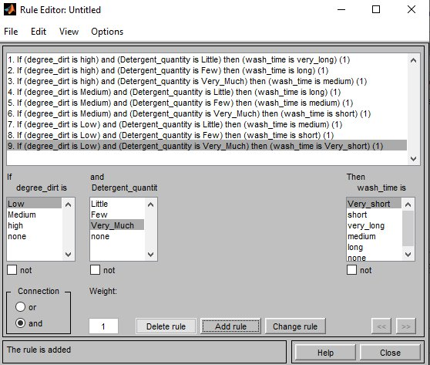m;

1:If degree\_dirt is Medium and detergent\_quantity is Little then wash\_time is long;

1:If degree\_dirt is Medium and detergent\_quantity is Few then wash\_time is medium;

1:If degree\_dirt is Medium and detergent\_quantity is VeryMuch then wash\_time is short;

1:If degree\_dirt is Low and detergent\_quantity is Little then wash\_time is medium;

1:If degree\_dirt is Low and detergent\_quantity is Few then wash\_time is short;

1:If degree\_dirt is Low and detergent\_quantity is VeryMuch then wash\_time is very\_short;

The decision which the fuzzy controller makes is derived from the rules which are stored in the database. These are stored in a set of rules. Basically the rules are if-then statements that are intuitive and easy to understand.

Membership Function - Detergent Quantity

The triangle membership function showing the linguistic variable of the detergent of quantity.

Membership Function - Degree Of Dirtiness

The triang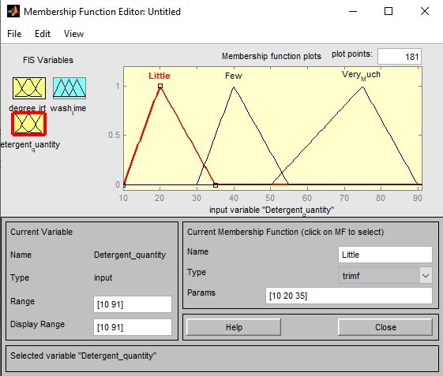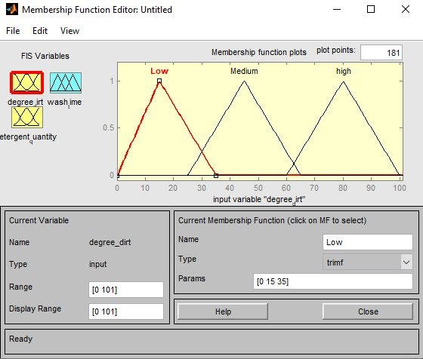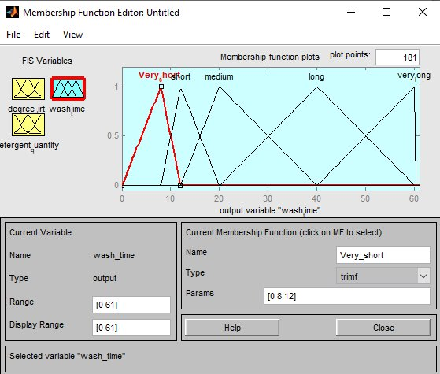le membership function showing the linguistic variable of the degree of dirtiness.

Membership Function - Wash Time

The triangle membership function showing the output variable of wash time

|  |  |  |  |
| --- | --- | --- | --- |
| **Input Variables** | **Range** | **Types** | **Values** |
| **Degree Of Dirtiness(%)** | 0-100 | High | 0-35 |
| Medium | 25-65 |
| Low | 60-100 |
| **Detergent Quantity(gr)** | 0-90 | Little | 10-35 |
| Few | 30-55 |
| VeryMuch | 50-90 |
| **Output Variables** | **Range** | **Types** | **Values** |
| **Washing Time(Min)** | 0-60 | VeryShort | 0-15 |
| Short | 12-20 |
| Medium | 18-30 |
| Long | 25-45 |
| VeryLong | 40-60 |

We have two input variables as Degree Of Dirtiness as gram and Detergent Quantity as percent they have ranges as 0-100 and 0-90 both have 3 types and this types have a range between value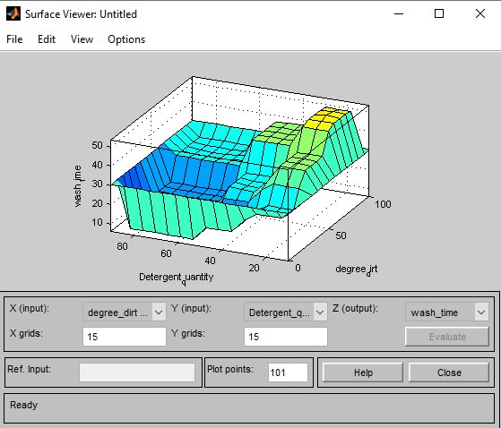s. We have washing time as minute also have range 0-60

As you can see above there is 3D Surface to represent our wash time value changing according to wash time and detergent quantity.

**Conclusion**

In conclusion we create our expert system using skfuzzy in python define input and output variables their ranges values and rules. We can find a wash time given input manually now. Our test inputs and outputs in below. I use my washing machine with 30 degrees temperature and using Persel Expert Colour for detergent also using a t-shirt which is %100 coton also dirtiness type is a mud.

| **Test** | **Detergent Quantity** | **Degree of Dirtiness** | **Output of Fuzzy System** |
| --- | --- | --- | --- |
| **Test 1** | 60 | 10 | 7.75 |
| **Test 2** | 60 | 30 | 10.3 |
| **Test 3** | 60 | 50 | 16 |
| **Test 4** | 60 | 80 | 24 |
| **Test 5** | 30 | 20 | 24 |
| **Test 6** | 30 | 50 | 35 |
| **Test 7** | 45 | 30 | 20.8 |
| **Test 8** | 50 | 90 | 35 |

Test 1: In result of our washing machine our t-shirt is clear after 8 minutes but there is a some detergent in detergent drawer.

Test 2: In result of our washing machine our t-shirt is clear after 10 minutes but there is a some detergent in detergent drawer.

Test 3: In result of our washing machine our t-shirt is clear after 16 minutes there isn’t any detergent in detergent drawer.

Test 4: In result of our washing machine our t-shirt is almost clear after 24 minutes

When we test with 30 minutes our t-shirt is clear.

Test 5: In result of our washing machine our t-shirt is clear after 24 minutes.

Test 6: In result of our washing machine our t-shirt is clear after 35 minutes,When we try with 25 minutes there is dirtiness in t-shirt also 30 minutes too.

Test 7: In result of our washing machine our t-shirt is clear after 20.8 minutes.

Test 8: In result of our washing machine our t-shirt is clear after 35 minutes,When we try with 25 minutes there is dirtiness in t-shirt but approximately 32 minutes, it’s clear.

As final conclusion we have to try tuning high deterrent quantity to because it’s have a time to decompose therefore we should try to tune high detergent quantity rules. On the other hand other rules with outputs looks good.

**References**

<https://www.slideshare.net/Harshgor06/fuzzy-logic-in-washing-machine>

<http://blog.onsitego.com/fuzzy-logic-means-washing-machine/>

<https://www.geeksforgeeks.org/fuzzy-logic-introduction/>

<http://www.bel.utcluj.ro/dce/didactic/sln/lab_eng/5WashingMachine/html/washing_machine.html>

[https://medium.com/deep-learning-turkiye/python-ile-bulan%C4%B1k-mant%C4%B1k-modellemesi-74459dc27308](https://medium.com/deep-learning-turkiye/python-ile-bulan%25C4%25B1k-mant%25C4%25B1k-modellemesi-74459dc27308)